Toronto Hydro Outage Map Project

# On-Premise architect using Open data platform

## Scenario 1

The data from the NMS system needs to be visualized real-time in an outage map using open source technology stack.

# 

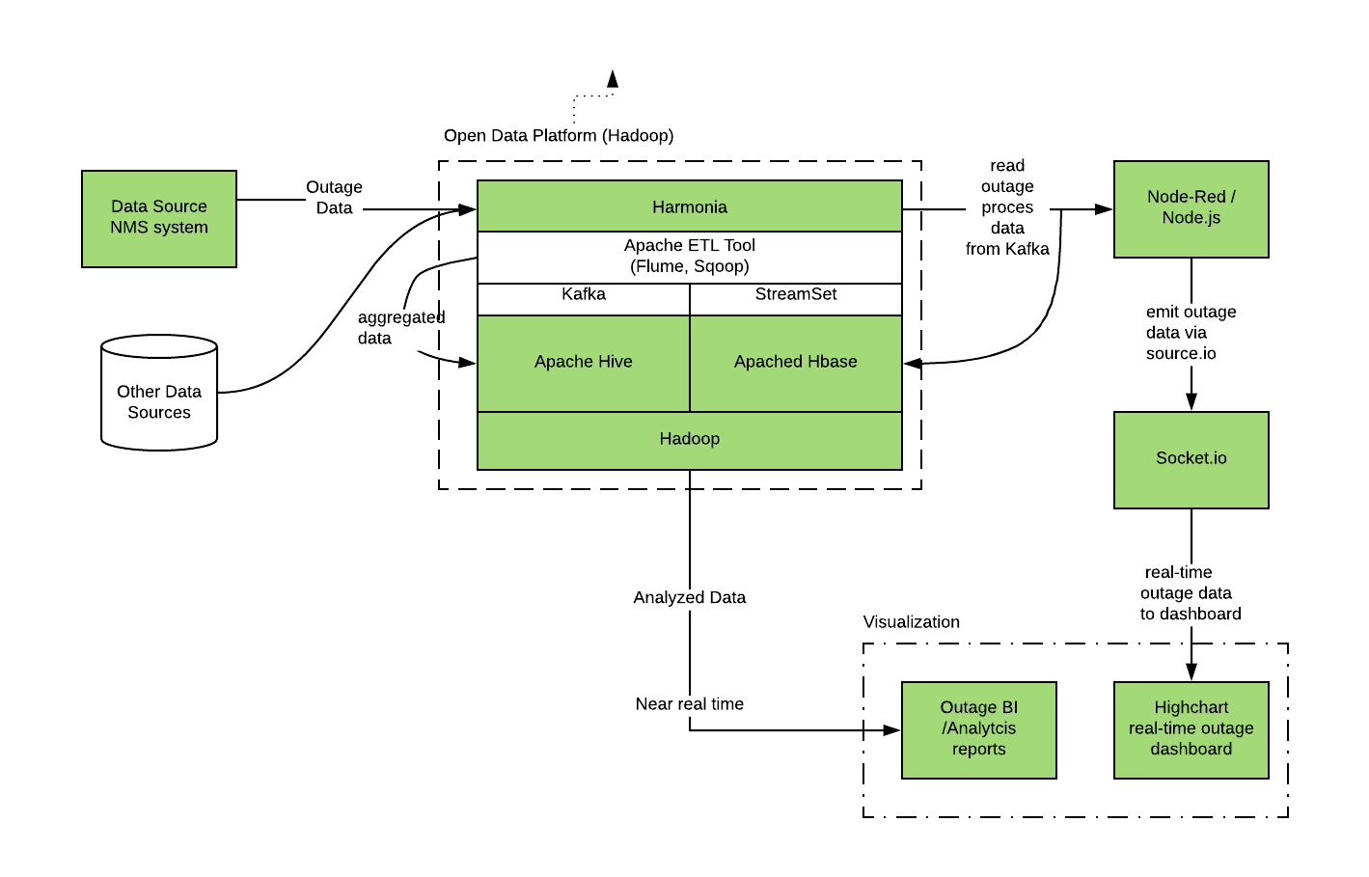

## Solution Ideation

The NMS data will be ingested using Harmonia (real-time or near real-time) and will be brokered using one or more Kafka topic(s).

The outage data will also be persisted into Apache Hbase as it was in the source. This is to allow us to further analysis on the outage data and apply ETL processing with other data sources in the Hive warehouse database.

Hive data warehouse will provide data for Business Analytics and other forms of Advanced analytics.

From the pure streaming data dashboard of the outage data, an application running Node.js or Node-red will read the data from Kafka topic provided by Harmonia and emits to web application that uses socket.io libraries. This data can then be presented in a dashboard using Highchart in a web browser.

The same data can also be presented using other visualization tools such as tableau.

## Scenario 2

On-Premise architect using MapR CDP

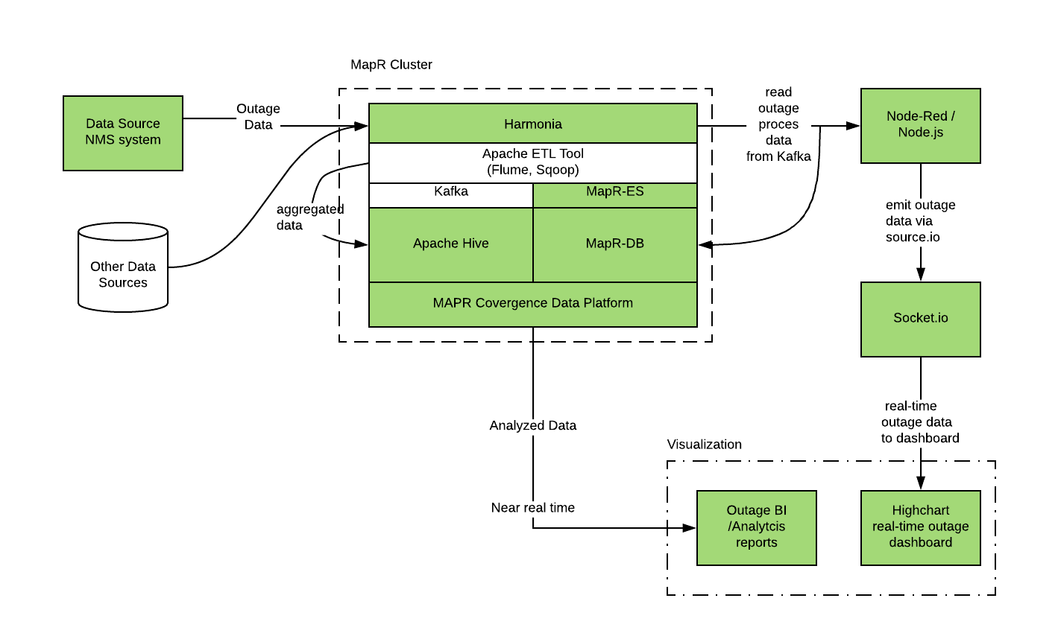

The same solution hold true except Hbase will be replaced by MapR-DB running in a MapR cluster.